

**California Polytechnic State University Pomona**

DEPARTMENT OF ELECTRICAL & COMPUTER ENGINEERING

IINTRO TO MICROCONTROLLERS LAB

ECE 3301L.03

Report #3

**LAB 4 – More Assembly Language Implementation**

Prepared by

**Kelly Williams**

**and**

**Isaac Bernal**

Presented to

Felix Pinai

September 26, 2024

# TABLE OF CONTENTS

TABLE OF CONTENTS 2

INTRODUCTION 3

Objective 3

Summary 3

DATA AND RESULTS 3

CONCLUSION 5

# INTRODUCTION

## Objective

This lab will allow students to implement further uses of the Assembly language through the introduction of arithmetic, logical, and branching instructions.

## Summary

This lab reuses most of the hardware setup from the previous two labs, expanding on our use of LEDs with the Pickit microcontroller. Additional LEDs will be used to show input and output bits of various arithmetic and logical instructions in Assembly through the use of DIP switches. Multiple software parts will be required for this lab, all coming together in the final part so students can debug the individual sections before combining them.

# DATA AND RESULTS

LED’s from left to right:

Zero flag, overflow, four output bits, RGB routine, four secondary input bits, four primary input bits.

Figure - One's Complement

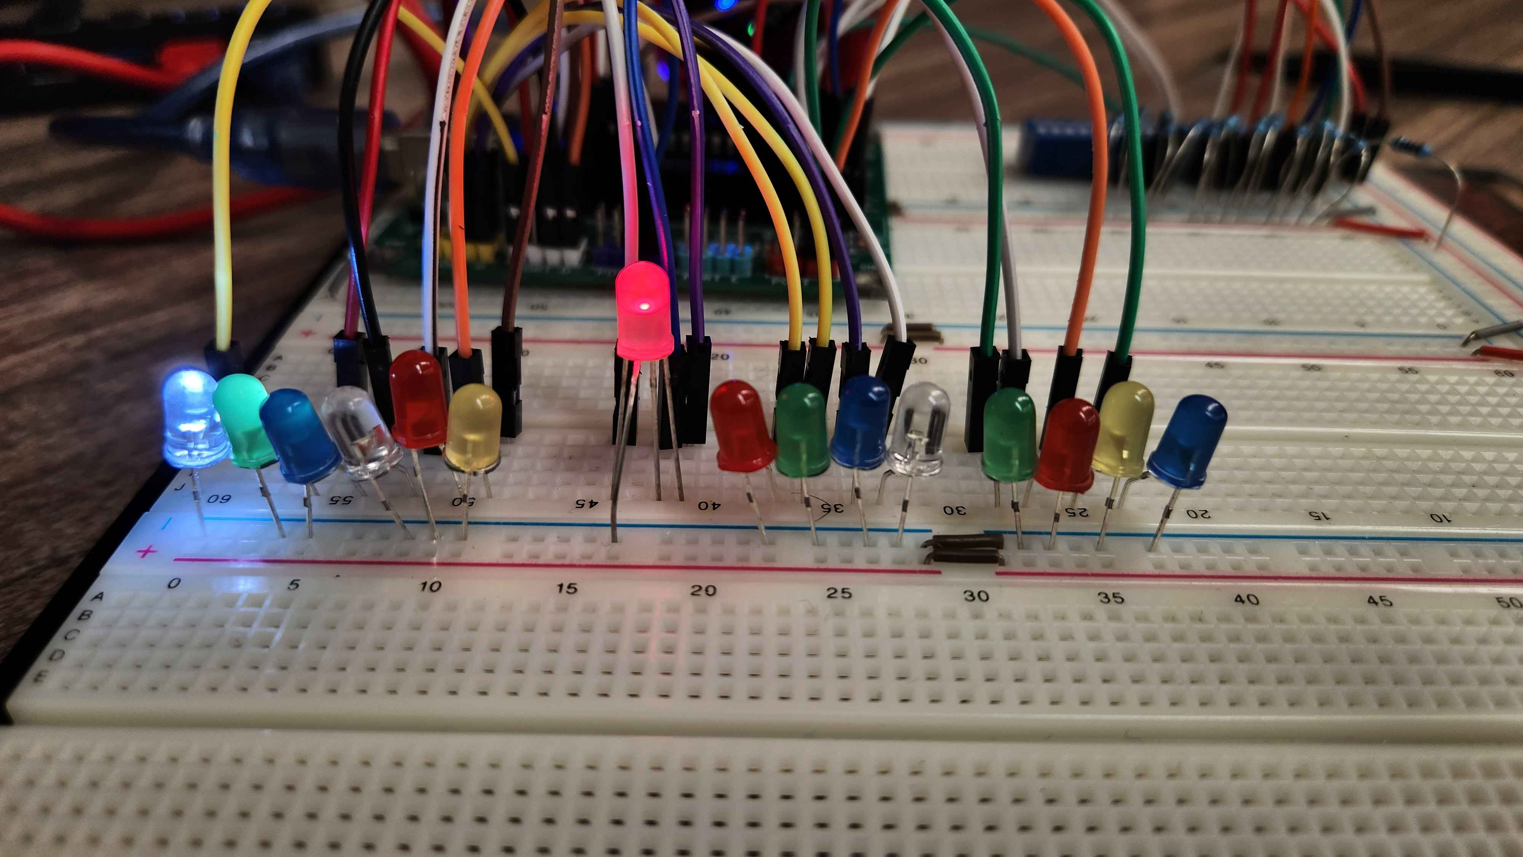

Figure - ADD operation with Zero Flag

Figure - ADD operation (2+2=4)

Figure - AND operation (0010 && 0011 = 0010)

Figure - OR operation (0010 || 0011 = 0011) LED is yellow, picture is just bad

Figure - XOR operation (0010 ^ 0011 = 0001)

Figure - BCD conversion (1010 + 0110 = 10000)

# CONCLUSION

This lab expanded on our knowledge of Assembly, allowing us to use arithmetic, logical, and branching instructions to complete a wider variety of applications of the language. Breaking up the final implementation into smaller, more manageable parts allowed for students to debug the code in sections to ensure they were functioning properly before combining them. The use of familiar hardware allowed for students to focus on the changes in the software.